Drag and Drop | There are three different drag and drop questions:  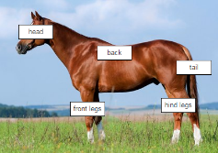  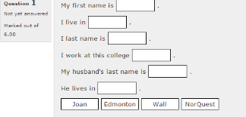  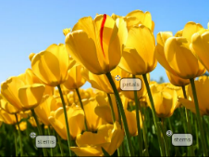  Drag and drop onto text, Drag and drop onto markers, Drag and Drop onto an image.
First create your quiz. | Follow the steps below to create a question in a quiz.  - Click the Quiz title on the course home page  - Click Edit quiz in the Administration block.  - Click on Add link  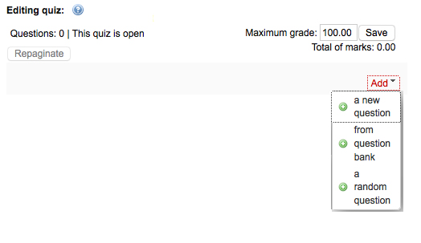  - From the drop down menu select a new question  - Choose the type of drag and drop question you would like to add from the pop-up window.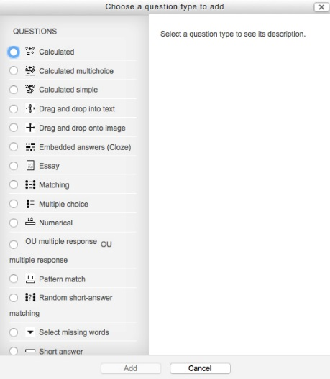  - Click Add button to view the settings page of the question type.
Drag and Drop into Text   | 1. Make a question name that describes the content of the question.  2. Write out your text giving answers using [[1]] to identify correct responses.  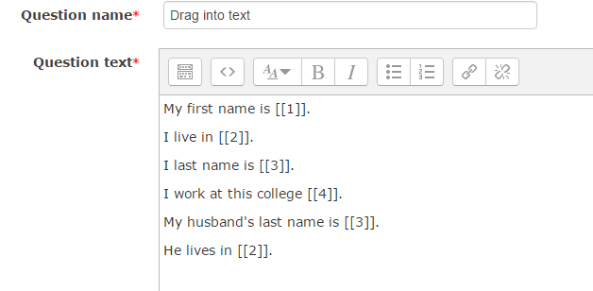  3. Review default mark and adjust as necessary.  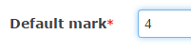  4. Identify correct responses. Remember you can use ‘unlimited’ to describe answers that can be used more than once. [Option- If you have a lengthy or varied topic assignment, you can colour code responses/answer blocks by designating different groups for answers.]  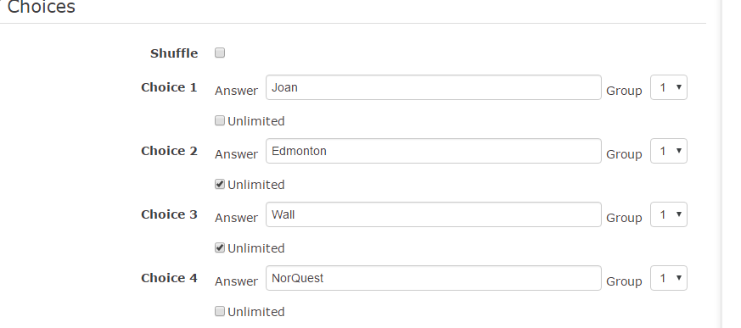  5. Decide on optional settings: combined feedback and multiple tries penalty and hints.  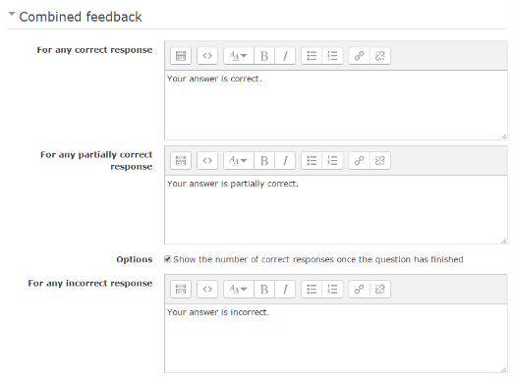  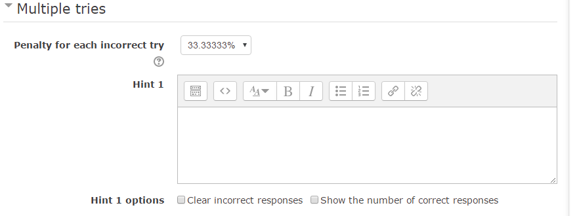
Drag and Drop onto an Image   | 1. Make a question name that describes the content of the question.  2. Give directions under ‘Question text’.  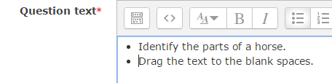  3. Review default mark and adjust as necessary.    4. Optional: General feedback- shown to all students regardless of the students’ response. (It may be used to show the correct answers.)  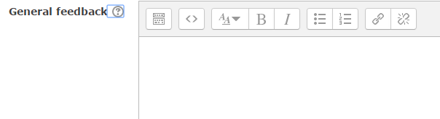  5. Drag your background image or choose a file on your computer.  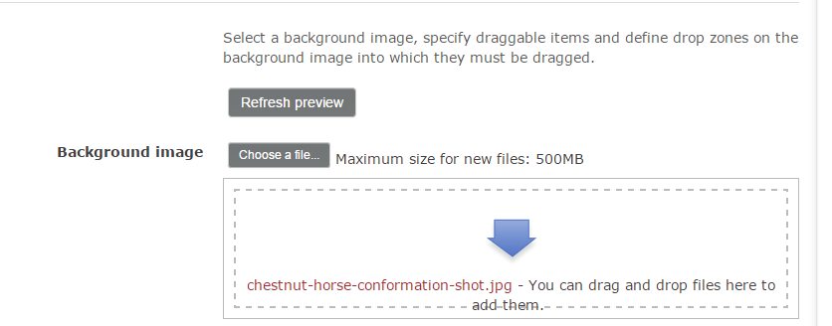
Drag and Drop onto an Image  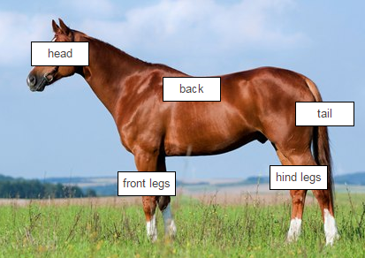 | 6. Draggable items: You may choose to drag text or images onto the background image. [Option- If you have a lengthy or varied topic assignment, you can colour code responses/answer blocks by designating different groups for answers.]  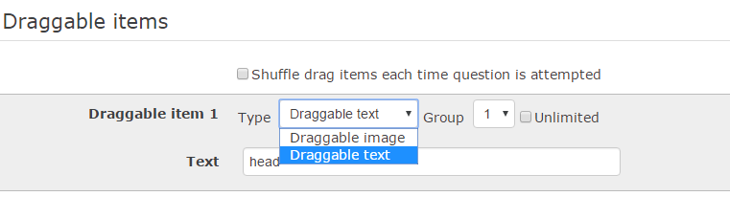  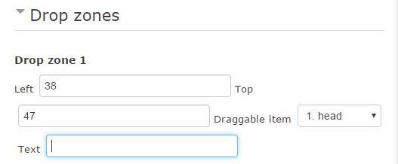  7. Drop zones: Your image is broken up into squares length 600 and width 400. Identify where you think the top left corner of your text or image should rest.  Left  Second Row  8. Decide on optional settings: combined feedback and multiple tries penalty and hints.  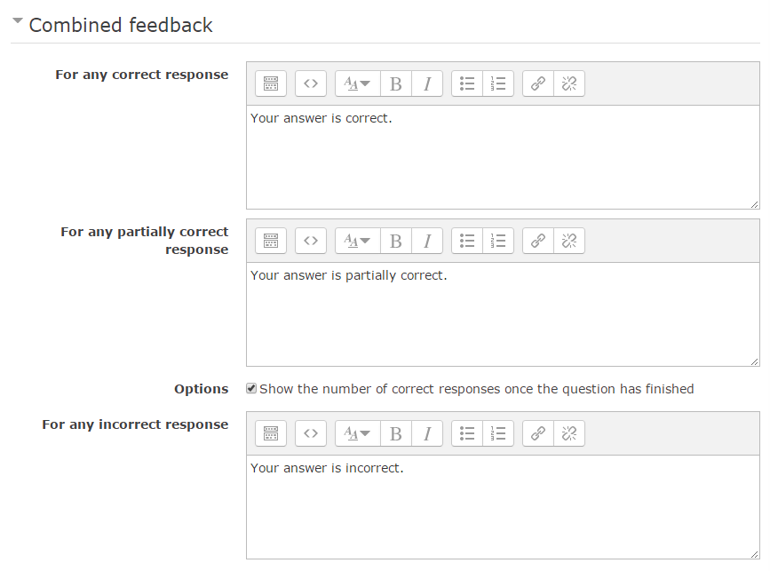
Drag and Drop onto Markers  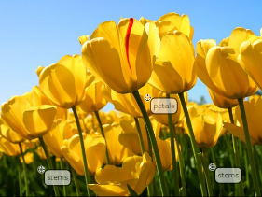  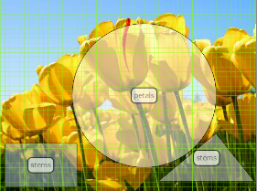 | 1. Make a question name that describes the content of the question.  2. Give directions under ‘Question text’.    3. Review default mark and adjust as necessary.    4. Optional: General feedback- shown to all students regardless of the students’ response. (It may be used to show the correct answers.)    5. Drag your background image or choose a file on your computer.    6. Identify your Markers. The number of times a response may be used, and whether you  Want the markers to be shuffled for every attempt.  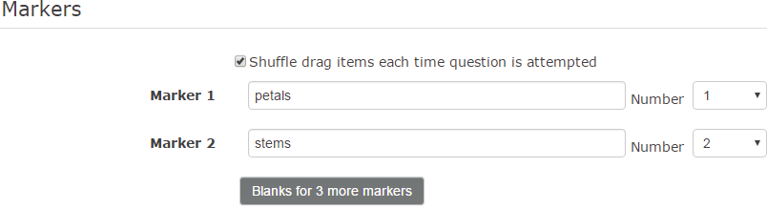

Drag and Drop onto Markers     | 7. Drop zones: Your image is broken up into squares length 600 and width 400.  You may choose to use a circle, rectangle or a polygon for your drop zone.  Petals circle 300,200;150 [x,y;radius]  Stem 1 rectangle 10,300;150,90 [x,y;l,w]  Stem 2 polygon 450,280;320;330,380;530,380  [x1,y1;x2,y2;x3,y3;x4,y4... (x1, y1 are the coordinates of the first vertex, x2, y2 coords. for second…)]  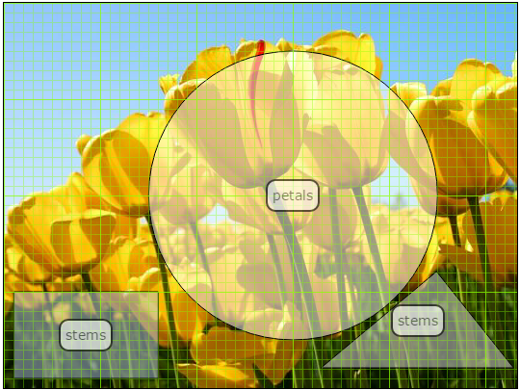  Y  X  8. Decide on optional settings: combined feedback and multiple tries penalty and hints.  